National Career Development Association
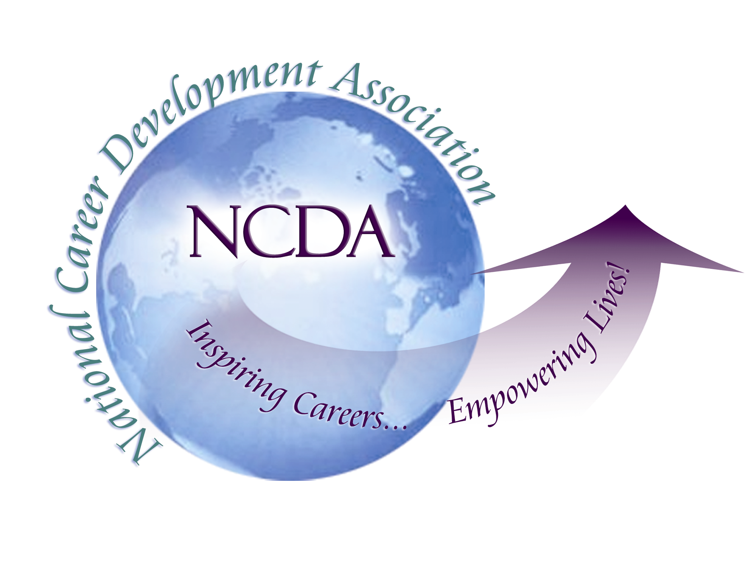
305 N. Beech Circle
Broken Arrow, OK 74012
918/663-7060
Fax: 918/663-7058
www.ncda.org

National Career Development Association
Leadership Academy
Action Learning Project Summary

Participant(s): James Westhoff

Board Mentor: Julia Makela-Panke, NCDA Ethics Committee

Leadership Academy Class: 2017

Project Title: The ethics/issues of implementing the new credentialing initiative

Project Description: This project was a qualitative survey of career professionals from state CDA boards to determine their perceptions of the new credentialing initiative being developed. The goal of the survey was to gain feedback from professionals in the field on the ethics and issues they see in implementing this initiative. Julia and I developed a four question survey with each question having two to three sub questions. I reached out to three current Presidents of state CDA boards to ask if their board members would be willing to participate. I sent the board members the questions and the Career Convergence article written by Connie Pritchard and Marilyn Maze that describes the initiative.

Ultimately, I had eight of the board members answer the questions first and then I followed up with interviews. The eight individuals came several work environments and educational backgrounds that I feel made the responses more representative of NCDA membership even though it was a small sample. One person came from K-12 and is new to the field, one that is retiring in private practice and counselor education and considers herself a coach/consultant, one that is a career advisor at a technical college, one that splits time between private practice and a 4-year liberal arts college career center, an Assistant Director of a 4-year college career center, an adult career specialist in continuing education at a college, a workforce development professional just recently graduated from a PhD, and another adult career specialist with many years of experience and many credentials.

The questions that were asked are included below:

Central Question:
What are the views of career focused professionals on the new credentialing initiative?

Questions for survey participants:
1.What are your overall feelings about professional credentials?
- Do you have a credential already?
  - If Yes,
Which credential do you hold, and how did you decide to pursue it?
How has your current credential helped you?
  - If No,
How did you make the decision not to pursue a credential?
2.What is your view of the five initial credentials that are proposed?
- How well do you think they cover the different aspects of our profession?
- Would you suggest any changes to the NCDA credentials?
3.What value do you see in these credentials?
- What do you think these proposed credentials add to the profession?
- Would these credentials make you change your membership status in NCDA? If yes, in what way?
- If you held previous credentials, would you perceive making any changes in those credentials in response to NCDAs new credentials?
4.With the implementation of these credentials what issues or concerns do you see?
- What ethical issues do you see in their implementation?
- What other issues are most important to you in their implementation?

Summary of responses:
Question #1. All of the participants agreed that credentials are important and add credibility to our field. The most important aspect of credentialing was that it requires career professionals to stay current and promotes life-long learning. A couple of participants felt that their degree and experience spoke for itself and that credentialing was not helpful to their careers. One participant felt that she had been practicing so long that the GCDF or other credentials were not needed.

Of the eight participants, only one mentioned interest in pursuing one of these credentials in the near future. This person was relatively new to the field. Three other participants would not pursue these new credentials in the near future, yet currently held GCDF credentials from NCDA. Three others felt no need to pursue a credential due to their master’s or PhD degree training and length of experience, while one participant expressed that she had been practicing so long that the GCDF or other credentials were not necessary.

Question #2. All but one of the participants felt that the five initial credentials made sense, were logical, and were manageable. The participant that disagreed felt that the credentials made sense for the professionals, but that they would be confusing to the consumer.
For changes, three participants suggested having a “Master Career Counselor or Specialist” designation instead of the Certified Master of Career Services or in addition to that category.
One participant felt there should be categories for Career Coaches and Career Consultants.
Four participants felt no changes were needed to the five categories.
Finally, one participant felt that it would be very important to have a streamlined process of taking current credentials and transferring them to new credentials. She said she would not want to have maintain the GCDF and one of these credentials as well.

Question #3. Sub-question a. Several of the participants felt that this credential process seemed more rigorous and it gives it more legitimacy than the current system. Participants felt that the credentials established a set of ethical guidelines that practitioners would be held accountable. One participant felt that it would create clearer boundaries for the amount of training necessary for specific kinds of interventions. One participant felt that she would need to see the person in action and see their talent rather than relying on a credential.
Sub-question b. All except one participant are current members of NCDA and they would remain members. Three of them would pursue these credentials most likely. Three would need to see more detail to make a decision whether to pursue. Two would not pursue at all because they are at the end of their careers and the one doesn’t see a category that fits her coaching/consulting role.
Sub-question c. Three of the participants would pursue one of the credentials. Three would not pursue because of their level of experience, with one of these people really questioning the credibility of credentials. Two people needed more information before they decide whether to pursue or not.
Question #4. One participant felt that there were too many categories and that the initiative was trying to do too much too soon. They felt it needed to be consistent and timely to implement the initiative.
The ethical issues seemed to revolve around the requirements of the application process and that it be a fair and transparent process. The major questions of these participants were the costs and how often people would have to renew the credential. One participant felt strongly that the process should be overseen by a third party with experience in credentialing, but with no ties to the field. Another felt very strongly that we need to be cautious as a profession to not mislead consumers about a career development professional’s level of training and experience. Finally, one participant felt that they did not have enough information to determine any ethical issues with this initiative. This person felt that there needed to be a balance between communicating the importance of credentials and more hoops for practitioners to jump through. This person was not sure of the true intent of this initiative (i.e., money making ploy, excluding certain groups). This person felt there needed to be clearer communication of the intent of this for both clients and professionals, and hopefully keeping it low or no cost.

Summary/Conclusion:

Overall, the respondents were very positive that this initiative is moving in the right direction. Most of them felt that the initial five categories made sense and were effective in covering most of the career development field. Though, some felt that there needed to be a name change of the Certified Master of Career Services to Master Career Counselor or in addition to that category.. In addition, one respondent felt that she was fairly ostracized from the NCDA because she considers herself a career coach/consultant and has never felt that NCDA was a place she felt welcome and that there should be a category for career coaches/consultants.

The other concerns are with how the decision making process of becoming credentialed will happen and that it be fair and flexible. There was also a concern that this initiative might marginalize many worthy career professionals because they lack the exact education or other requirements. A major concern was what will it cost people to become credentialed and what will the process of recertifying look like. The major conclusion I came to was that these professionals were very open to seeing this initiative be successful, but they were apprehensive because they had no idea how it was being implemented or managed.

Results/Recommendations:

I think the results of this survey are very compelling even though the number of participants was lower than expected. Since it was a qualitative study, I believe the results were much deeper than doing a quantitative survey with more members. I think the questions that Julia helped me develop were very strong and we were able to get deep responses to important issues with this new initiative.

My recommendations are that the development of this initiative must be very transparent and shared widely with membership and even non-membership so that people understand the goal and process of the initiative. It was clear in my small survey that these participants knew very little about the initiative and the goals and intent of why it was being developed. Finally, I recommend that continuing to include feedback from professionals using these questions or similar questions might garner very good ideas to include in the initiative. It would also increase awareness and possibly the credibility of the initiative.

