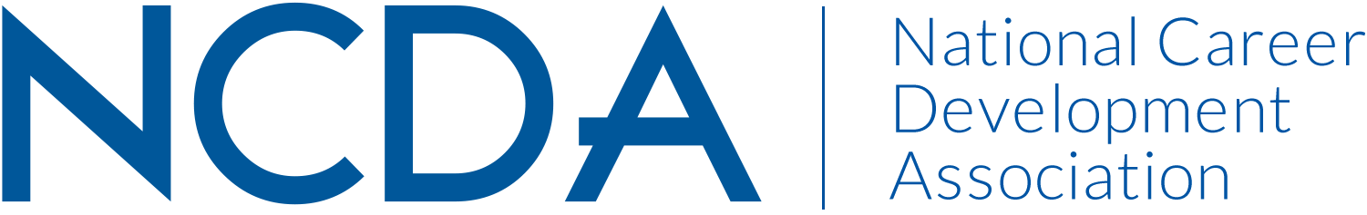

NCDA TECHNOLOGY COMMITTEE
March 15, 2022

Committee Chairs

Dirk Matthews, dirkwmatthews@gmail.com, Senior Director of Alumni Relations, Columbia College Chicago, Chicago, IL (Co-chair)

Jaana Kettunen, jaana.h.kettunen@jyu.fi, Professor, Finnish Institute for Educational Research, University of Jyväskylä, Finland. (Co-chair)

Committee Members
Barbara Thomson
Darrin Carr
Dawna Reeves
Debra Ruddell
Dirk Matthews
Ellen Weaver Paquette
Jaana Kettunen
Janet Wall
Julia Panke Makela
Katherine (Kathyy) Battee-Freeman
Leigh Farrar-Freeman
Lisa Raufman
Lynne Orr

Committee Activities to Date

- Reviewed and confirmed membership of committee
- Reviewed and updated 26 sections of the Internet Sites for Career Planning pages on the NCDA Website
- Continued quarterly reviews of new resources for internet sites
- Submitted 7 Tech Tips
- Provided reviews for updates of Chapter 7 of the Facilitating Career Development Manual to the Training and Education Council

Projected Plan/Work Completed through September 30.

- Survey the NCDA membership body regarding their use of technology in career development
- Utilize survey results to generate a white paper on technology in career development
- Several members will present at the NCDA Conference this June about the above work
- Continue with quarterly reviews of new resources for the Internet Sites page
- Continue generating monthly Tech Tips
- Research platforms for mentorship programs to support the NCDA Mentorship Initiative

Budget Requests:
Upgrade to the pro-version of Survey Monkey for surveying NCDA Membership. Cost approximately $25/month for 3 months.

