NCDA COMMITTEE MID-YEAR REPORT
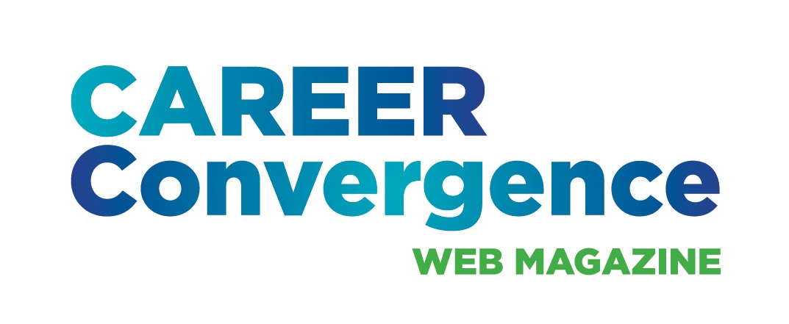

CAREER CONVERGENCE WEB MAGAZINE
March 7, 2023

Melanie Reinersman, Editor, webeditor@ncda.org

Associate Editors: Natasha Barnes, David Dietrich, Linda Evans, Melissa Fickling, Kyle Inselman Amy Pierce-Danders, Vonya Hodrick, Elyse Pipitone, Billie Streufert, Jerilyn Wagner
Field Editors: Mason Murphy, Janine Rowe, Willa Smith

Activities to Date

- Brainstormed ideas and kicked-off celebration of the 20th anniversary of the web magazine, including a new logo, a social media campaign and article in Career Developments magazine
- Created new issues on Oct 1, Nov 1, Dec 1, Feb 1 and March 1, bringing the total issues up to 208 (since 2003)
- Published 6 new articles, plus one Tech Tip, each month. Electronic distribution to approximately 24,800+ emails on the first of the month
- Recorded 30 day hit rate for each issue’s articles
- Welcomed two new Co-Associate Editors (Features; Independent dept), increasing the diversity of the editorial board
- Held a conference call on Dec 5, 2022
- Registered with iStock for better quality/selection of images for articles
- Moved forward on the content analysis
- Granted reprint request to Asia-Pacific CDA to use any articles, anytime. Fulfilled 4 requests for CEs
- Monitored comments posted on articles
- Tweeted each month, with links to the issue and each article
- Selected (by editors’ votes) the annual “Career Convergence Recognition Award” winner.

Projected Plan/Work Completed through September 30.

- Continue to publish monthly web magazine and promote the anniversary celebration.
- Meet at the conference in Chicago; present the web magazine in two sessions (one a joint presentation with Career Developments editor)
- Complete the content analysis and ways to share the results at the conference

