National Career Development Association
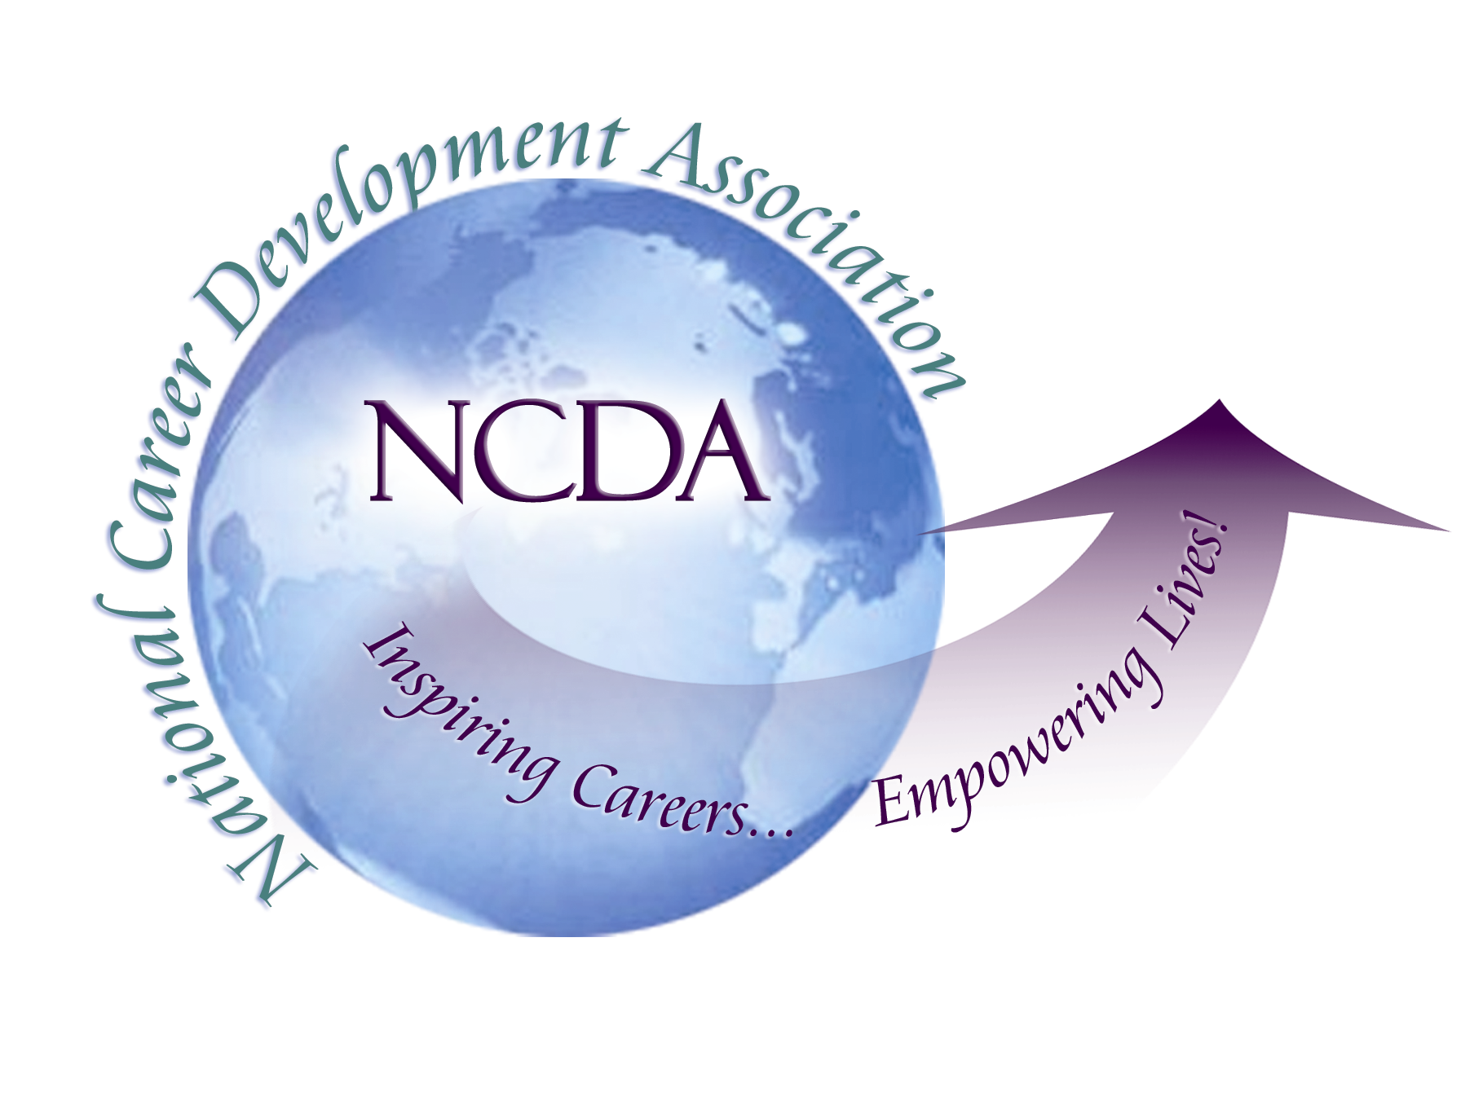
305 N. Beech Circle
Broken Arrow, OK 74012
918/663-7060
Fax: 918/663-7058
www.ncda.org

National Career Development Association
Leadership Academy
Action Learning Project Summary

Participant(s): Jennifer Del Corso

Board Mentor: Cheri Butler

Leadership Academy Class: VIII

Project Title: An Inquiry into the Utilization, Communication, and Collaboration of Leadership Academy alumni and Brain Trust members by the NCDA Board

Project Description: The purpose of this proposal is to investigate how the “Brain Trust” and the Leadership Academy alumni are utilized by the NCDA board by examining communication between the groups. Specifically the project seeks to better understand the:
- Perceived degree of involvement of BT/LAA- (to what extent do they feel their opinion is invited (sufficient, or not enough; and whether they feel content with the degree of their involvement)
- Preferred form of communication (how often and what type) of LAA and BT from the Board, and consequently the Board’s preferred communication with LAA, BT
- Perception of communication between groups
- Suggestions for any strategies or activities that may increase communication or involvement

Summary/Conclusion:
- Communication
  - LAA wants more communication with the NCDA Board
  - NCDA is open to more communication
  - Brain Trust overall does not want more communication with the board either because they do not see the group’s utility or because they do not feel current communication is meaningful
- Frequency of Communication
  - LAA wants quarterly communication
  - NCDA wants semi-annual communication with both groups
  - Low response from BT- prefer semi-annual
- Communication Format
  - LAA: prefer Listserv, Social Opportunities; and Tasks Assigned
  - Brain Trust prefers Email & Tasks Assigned

Results/Recommendations:
- Create an LAA listserv that LAA participants can choose to sign on/sign off to in order for NCDA to share information and/or receive feedback from LAA; Participants that are not interested can simply unsubscribe to the listserv
- Help transition LAA members into committee work as they are leaving LA
- Create a new name for the “Brain Trust” by soliciting feedback/suggestions from the group. (This could be another LA project). Overall individuals who emailed me did not like the name of the group which can impact their desire to participate/belong.
- Clearly identify members of the “Brain Trust” that still seek to be involved. Create an email list of only those members and either email them directly or create a listserv when NCDA members have questions or wish to gather additional information.
- Create a more meaningful meeting between “Brain Trust” members and all of the NCDA Board at the NCDA conference so that the BT is utilized for its knowledge– not simply a social group
- Discuss with NCDA Board Members about the possibility of assigning each member a “Brain Trust” mentor

