National Career Development Association
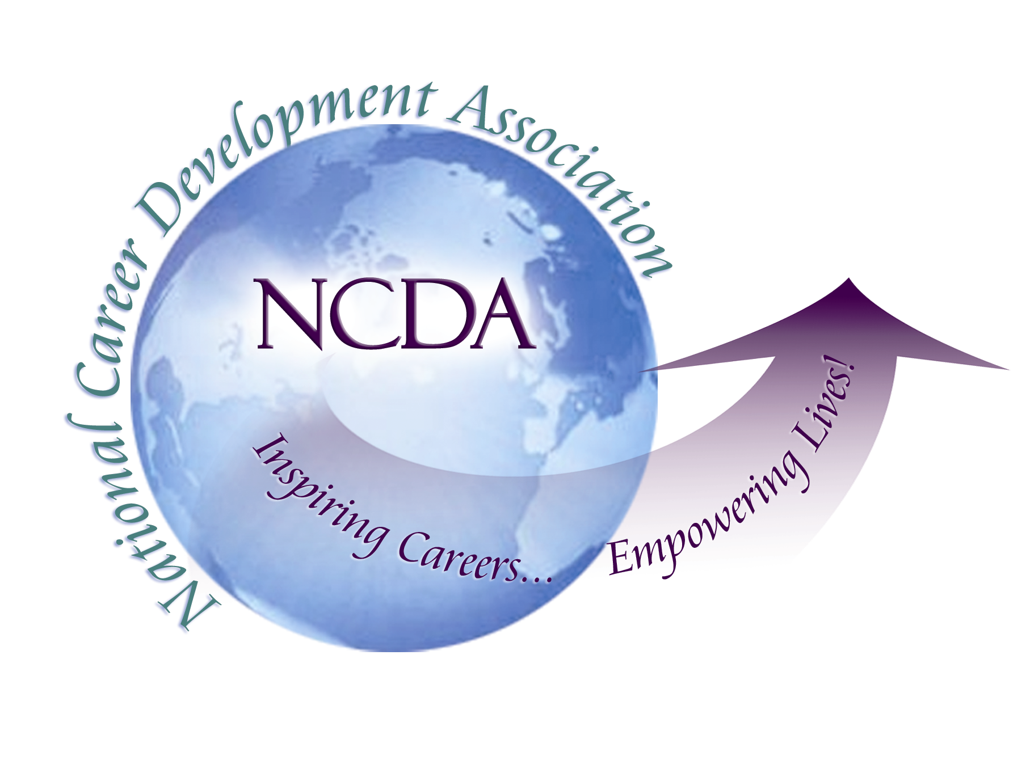
305 N. Beech Circle
Broken Arrow, OK 74012
918/663-7060
Fax: 918/663-7058
www.ncda.org

National Career Development Association
Leadership Academy
Action Learning Project Summary

Participant(s): Nena Davis

Board Mentor: Rebecca Dedmond

Leadership Academy Class: 2013-2014

Project Title: Training Quality Taskforce (TQT) – Evaluative Research

Project Description: I originally proposed to explore opportunities for NCDA to provide training options, such as the Career Development Facilitator (CDF) training, to related organizations, such as the Society for Human Resource Management (SHRM), in order increase our ability to reach new potential constituent audiences and to build NCDA membership. When it became apparent that the NCDA Board was already considering how to partner with organizations such as SHRM by becoming an “Approved Program Provider”, I was invited to join a newly appointed task force, along with Recbecca Dedmond, Marilyn Maze and Hyung Joon Yoon in order to explore the feasibility of becoming a training provider for other organizations. We decided to name the taskforce the Training Quality Taskforce (TQT) and to determined our goal to be “to implement a software solution that will allow NCDA to collect evaluations of all training opportunities, from presentations at the conference to CDF training” in order for us to become a service or training provider to organizations such as SHRM. Aside from participating in the meetings, my project became to research the specific qualifications required by various organizations, including SHRM, the American Psychological Association, the National Association of Social Workers, the International Coach Federation, and many others and to compile my findings so that they could be presented to the NCDA Board for consideration. I also compiled examples of evaluations and evaluative questions currently in use by these organizations to be used as a basis for creating our own survey.

Summary/Conclusion: My findings from researching the service and training provider application process and requirements for over fourteen organizations indicated that quantitative program evaluation is clearly required by a majority of the associations that work with Continuing Education (CE) programs and providers. This research was presented to the Board, who determined that TQT should proceed with implementing an evaluative process. My fellow TQT members and I continued to work to develop a format and a technological means by which to gather the quantitative program evaluation.

Results/Recommendations: The final result of the TQT was to design and implement a survey so that we can gather the evaluation data required by SHRM and many other organizations in order to be able to provide their members with trainings. This survey has been implemented for the first time for this conference. The questions have also been sent to the programmers who support NCDA , who are working on making this information more easy to gather through incorporating it into NCDA’s current software. My final recommendation is that NCDA conference attendees complete the surveys for the conference, because it really is important to help us in this endeavor, and that NCDA continue to explore opportunities on how to become a training service provider for SHRM and other organizations.

