National Career Development Association
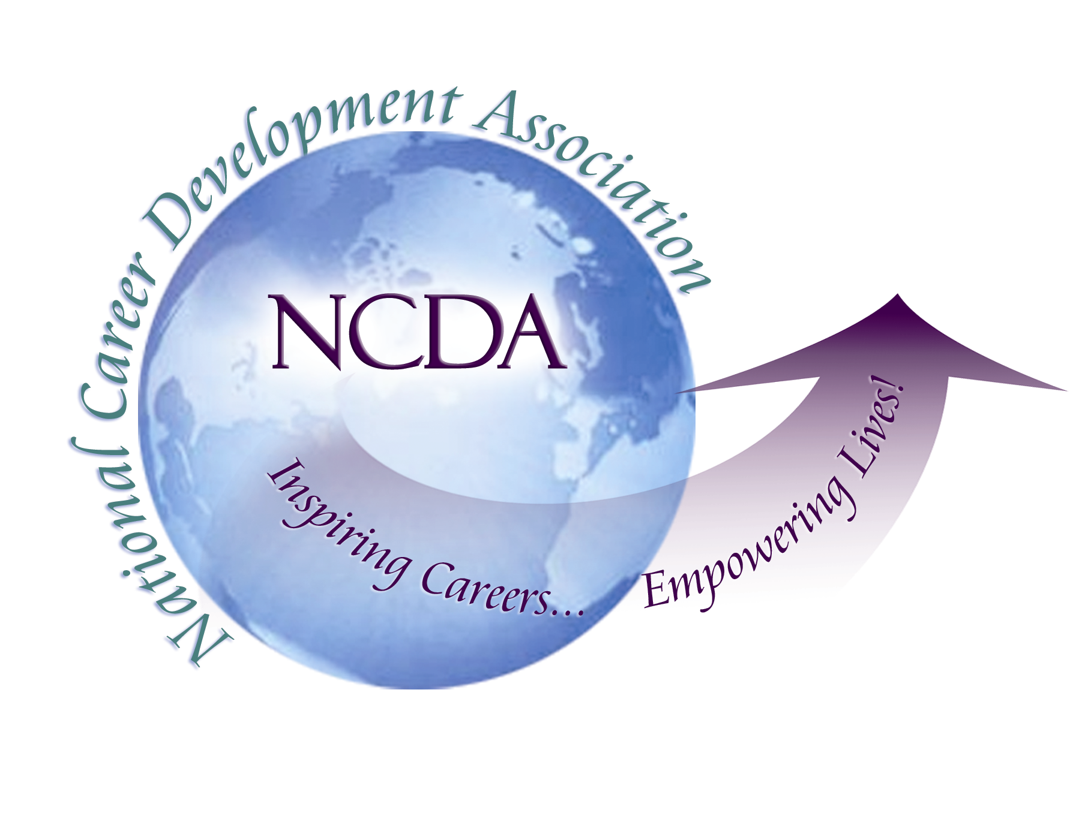
305 N. Beech Circle
Broken Arrow, OK 74012
918/663-7060
Fax: 918/663-7058
www.ncda.org

National Career Development Association Leadership Academy
Action Learning Project Summary: There are over 245,000 school counselors supporting 54,876,000 PK-12 students with little information and resources for classroom career development. To build membership, NCDA should consider filling this gap and create an interactive, e-classroom to allow school counselors to share lesson plans and techniques to support PK-12 career development.
Participant(s): Robin Cleveland
Board Mentor: Dr. Rebecca Dedmond
Leadership Academy Class: 14
Project Title: Innovation with Impact: PK-12 School Counseling & Career Development
Project Description: In 2013, CACREP reported there were 224 accredited school counseling graduate programs with 10,221 students compared to 8 career counseling programs with 168 students suggesting school counselors are the primary source of information on career concepts, theories and best practices for PK-12 students. Most school counseling graduate programs offer a single career development course underpreparing school counselors to meet the needs of 54 million enrolled students in today’s economy. In an effort to better prepare graduate students, I developed a short curriculum that emphasized practical application, tools and lesson plans for PK-12 classrooms integrating current theories. The student manual, Facilitation of Career Development, also was used as a resource. To assess confidence and competency in delivering PK-12 career development lessons and materials, I asked 12 Masters level students to take the GCDF self assessment before and after the class. In addition, final projects were assessed for developmentally appropriate content and creativity.

The course focused on three areas: individual school counselor career self-concepts and abilities, student decision making experience, and the practical application of theories and concepts in the PK-12 classroom. School counselor values, ethics and decision making styles were evaluated by developing personal career genograms and integrating conflict resolution training materials offered by the Harvard Negotiating Project and the Human Resources Department at the George Washington University. The goal was to improve school counselors own career self-concept and professional development as a foundation for helping others. Student decision making styles and self-concepts were considered in light of narrative (Savickas), transition (Schlossberg) and happenstance (Krumbolzt, Amundsen) theories. Case studies and project presentations of a lesson plan for a school based population strengthened practical interpretation and application.

Summary/Conclusion: The average score on the pre-test which considers knowledge and competence in career planning services, work force trends and assessments, 65%. Post test showed an improvement of 22.5 points to 87.5%. Four of the twelve graduates are now focused on career counseling in educational settings. These results along with impressive final projects addressing career development for children with special needs to projects on college alternatives demonstrate the impact of brief, intensive career counseling interventions which fill an urgent gap in counselor education.

Results/Recommendations: Given the current gap in career counseling resources for PK-12 students, NCDA could become a destination of choice for over 248,000 school counselors by offering an interactive e-classroom to upload and share ideas and lesson plans. Other available school counseling websites target psycho-social development. The results of this project demonstrate both need and immediate impact when career development best practices are shared with school counselors.

