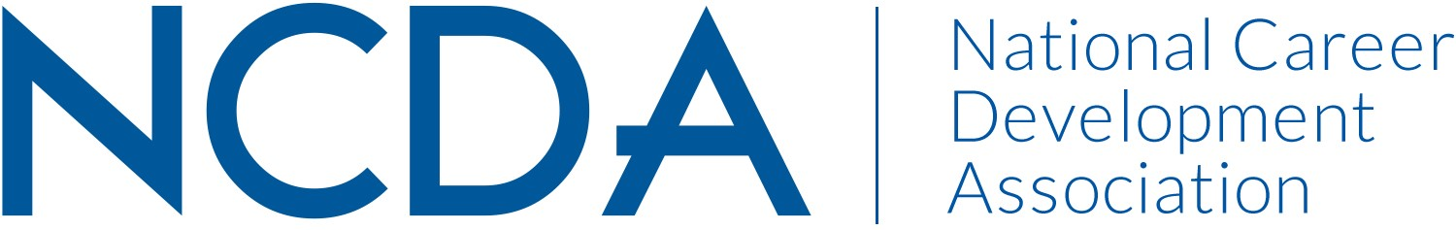

NCDA COMMITTEE REPORT

MEMBERSHIP COMMITTEE
March 15, 2024

Committee Co-Chairs:
- Dr. Mary Edwin (edwinmo@umsl.edu)
- Dr. Heather Robertson (robertsh@stjohns.edu)
List Committee Members (no contact information required)
- Emily Gomez (egomez@hireheroesusa.org)

Committee/Council Activities to Date

- Attended NCDA Committee Meetings on 2/13/2024
- Met with President to review five-year plan announced at 2023 Annual Conference and discuss Year-Two Activities 2/6/2024

Projected Plan/Work Completed through September 30.

- Review results of conference membership campaign received from Executive Director on 9/12/2023
- Recruit new members to the membership committee
- Repeat membership drive at NCDA 2024 Conference
- Launch (relaunch) membership needs survey

Suggested length: limit to one page

Submit to your board liaison electronically to your board liaison with a copy to dpenn@ncda.org by March 15, 2024. Please include a copy to your board liaison.

Budget Requests:
No new budget requests beyond incentives for membership drive and survey similar to those provided at 2023 conference.

